Algorithm for the North Sussex Judo

Start

1. Display the training plan of judo that includes 3 levels with fees. (E.g., Beginner - $25.00, Intermediate - $30.00, Elite - $35.00)
2. Display Weight Categories based on Kg.
3. Display other information such as 5 maximum hours of private coaching, and Intermediate and Elite level can only enter competitions, and date of competitions.
4. Show the prompt to user to enter their information:
   1. Name
   2. Training plan which includes 3 levels: Beginner, Intermediate, Elite.
   3. Current weight in Kg.
   4. Competition weight category.
   5. Option to add the numbers of private coaching (max is 5)
5. Whether can enter the competition validate:

* If the training plan not is "Intermediate" or "Elite"
  + then display "Beginner level can't enter competition".
* If not
  + then ask "Do you want to enter competition?".
    - if yes, fee will be the $22 per competition. (Number of competitions * competition entry fee)
    - if no, no competition fee.

1. Calculate the training fees:

* Calculate the fees based on the chosen training plan.
  + if user chooses "Beginner" the weekly fee will be $25 and for a month it will be $25 * 4
  + if user chooses "Intermediate" the weekly fee will be $30 and for a month it will be $30 * 4
  + if user chooses "Elite" the weekly fee will be $35 and for a month it will be $35 * 4
* Calculate the additional fees for private coaching (optional)
  + if user choose the private coaching the fee will be cost based on the number_of_hours * $9

1. If user input is not valid during the 4 to 6 steps it will return and display the suitable error messages and return to step 1
2. Output

* athlete name
* chosen training plan
* current weight in kg
* competition entered in kg
* competition entered in this month
* private coaching hours (optional)
* total cost of training plan, private coaching and others.

1. Repeat the step 1 to 8 for each athlete.
2. Display the Farewell message.

End

Flowchart of the North Sussex Judo

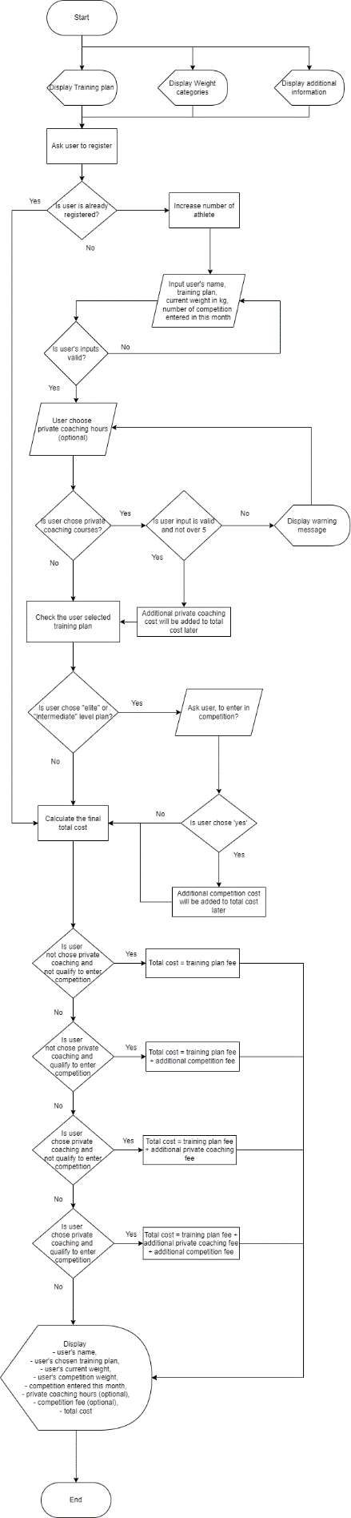

Higher resolution flowchart: <https://raw.githubusercontent.com/saihanhtet/SchoolProjectLithan/main/ECMM_HNDC_PFS_0324/ProgrammingFoundations/assignment1/solution/judoFlowchart.drawio.png>

<https://drive.google.com/file/d/1k2FnigFESifBkUUuLGEiUnV-DPlqLz6f/view?usp=sharing>